IB at LCCHS

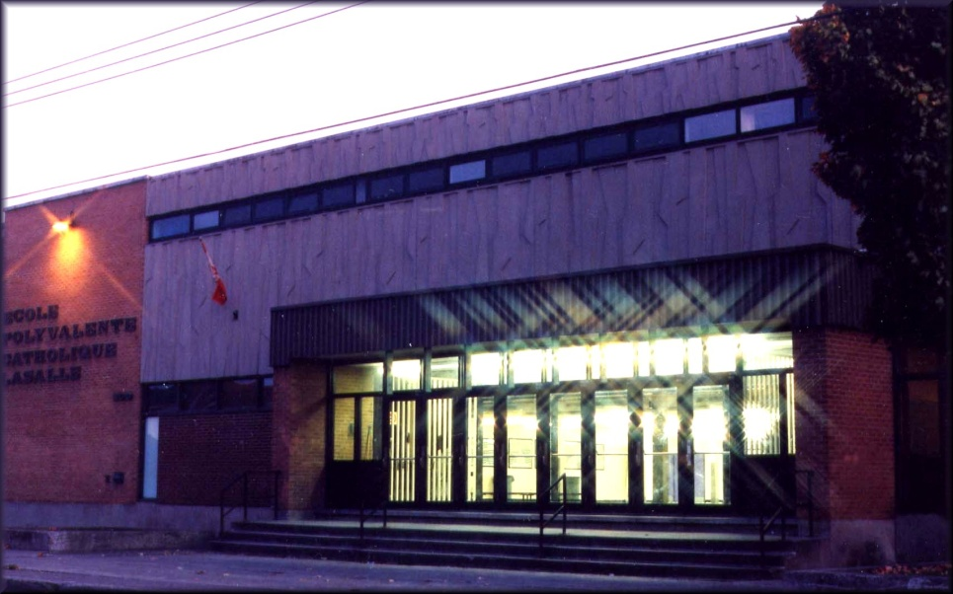

“****The International Baccalaureate aims to develop inquiring, knowledgeable and caring young people who help to create a better and more peaceful world through intercultural understanding and respect****.”

What is the International Baccalaureate Organization?

The IB is a non-profit international educational organization that offers schools three programs of international education. The students have the same discipline subjects (Language A and B, Mathematics, Physical Education, Humanities, Technology, Sciences and Art) but the emphasis is more on the interrelatedness of the subjects. The one offered at LCCHS is the MYP or Middle Years Program that is designed for students aged 11 to 16. The IB offers curriculum materials, assessment procedures, teacher training workshops, school authorization and program evaluation.

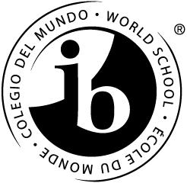

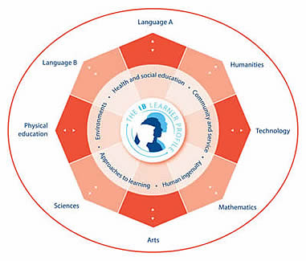

What are the Areas of Interaction?

The Areas of Interaction (AOI) are themes incorporated in each of the eight core subjects. These themes are intended to improve the level of learning by making connections with the world around us. The Areas of Interaction include **Environments, Approaches to learning, Human Ingenuity, Community and Service, and Health and Social Education.**

September 2012

How is the IB different from the other programs offered here at LCCHS?

While all programs are expected to follow the provincial requirements, the IB has in addition the following:

* One IB report card will be distributed in the month of June in addition to the provincial report cards.
* All eight core subjects use a specific set of published IB criterions or rubrics by which all students are assessed against. Each course has its own designated set of criteria which evaluate student work according to specific scales rather than percentages.
* All students are expected to complete a certain amount of Community service hours a year. All IB students must complete a total of 50 hours by the time they graduate. See our Community and Service coordinator, Ms. Intrevado, for more information.
* All teachers are taking part in interdisciplinary teaching. This method of teaching is encouraged to promote the interrelatedness between disciplines.
* All students must create a portfolio of their best work throughout the year for each subject. Students also include community and service hours.

**Junior levels: via internet Senior levels: via USB keys**

* In their final year, all IB students must complete a personal project whereby each student selects a preapproved topic and a mentor throughout the duration of the project

**Community and service hours**

Level 1 = 5 hours

Level 2 = 5 hours

Level 3 = 10 hours

Level 4 = 15 hours

Level 5 = 15 hours



IB Coordinators

Mme. Canty-Homier:

[jcanty@lbpearson.qc.ca](mailto:jcanty@lbpearson.qc.ca)

Ms. Intrevado:

[aintrevado@lbpearson.qc.ca](mailto:aintrevado@lbpearson.qc.ca)

M. Sicoli:

[msicoli03@lbpearson.qc.ca](mailto:msicoli03@lbpearson.qc.ca)

Web Site:

[***www.ibo.org***](http://www.ibo.org)

[***http://lcchs.lbpsb.qc.ca***](http://lcchs.lbpsb.qc.ca)

What is the academic expectation for IB students?

Once enrolled, they must adhere to high academic standards. More specifically, they must pass all courses and maintain a 70% overall average. Another characteristic of IB students is a keen sense of curiosity about the world that surrounds them.

Do students get special recognition for participation in a MYP program?

Once all expectations for both the provincial and IB requirements are met in their final year, students will receive both a provincial diploma and IB in house certificate.

What is LCCHS IB status?

Learning to care… Caring to learn.

Evaluation visits occur every 4 to 5 years. L.C.C.H.S. received a renewal of its IB status in 2010 with a highly commendable approval of our implementation of the program. While the school is fully accredited, we are in preparation for our next evaluation visit in 2014-2015

Caption describing picture or graphic.

September 2012

Page 2